Med-X AI: Thorax Disease Detector

Marla Capistran, Ronaldo Simbana, Leanna Machado, Anthony Munoz,

Prithvi Raimangya, Filippo Zalloco, Rahul Nayanegali, Christopher Ospina

SeidenbergSchool of Computer Science and Information Systems

Pace University, New York, NY, USA

Abstract— Currently, radiologists’ workload has increased significantly due to two main reasons – patient volume has grown, and the talent pipeline has decreased. In addition, the current number of radiologists is insufficient to balance their workload of training recent medical school graduates and tending to all patients equally. Consequently, these industry challenges are the root causes of burnout and long shifts compounding the degree of human error. A chest X-ray AI solution can alleviate the radiologist's workload by automating the detection of known chest conditions, thus enabling radiologists to concentrate on the remaining cases, often more complicated, and improving their workflow.

This paper presents the Thorax Disease Detector that utilizes AI to classify X-ray images and provide a preliminary diagnosis. This solution connects radiologists, physicians, and patients in one application, thus reducing the time it takes for patients to receive their diagnosis and improve physician workflow.

Keywords— Machine Learning, TensorFlow, X-Ray, Keras, Firebase, Convolutional Neural Network (CNN), Image Classification, Object Detection, Thorax, Radiologist, CheXpert, Category-Wise Fine-tuning

1. Introduction

Today, X-rays are widely used by hospitals to diagnose various medical conditions. They detect bone fractures, tumors, other abnormal masses, pneumonia, injuries, calcifications, and foreign objects [1]. X-rays are the most common and widely available diagnostic tool as it shows abnormalities better than more sophisticated tests. An X-ray session typically lasts 10 minutes and is sent as film or digital files. X-rays cost less and take less time than CT and MRI scans. Additionally, X-rays make no noise and do not require a confining space like an MRI [2]. X-rays are not harmful, because the dose of radiation is about the same as what you would receive from the general environment in one week [3].

Once an X-ray is created a radiologist must analyze and interpret the image to conclude a diagnosis. Radiologist workload has increased over time. Expert radiologists know how normal images look and have learned to process information from an image at a rapid initial stage of processing. Additionally, some images contain obvious anomalies that a viewing time of a faction of a second is sufficient for accurate determination. On the other hand, subtle abnormalities may require direct visual fixation for identification [4]. Depending on the complexity of the scan radiologists may perform an initial read and then consult a colleague [5]. Thus, the time it takes a radiologist to read an image varies depending on their experience, task complexity and procedure type (mammography screening vs thoracic).

AI machine learning aids a radiologist as it provides a second reader in real time. AI can be accurate at detecting abnormalities as it is trained with a multitude of images. It should be used as a supplement to human radiologists and thus improve accuracy [4]. Combining AI and radiologist assessment will improve efficiency by prioritizing cases, reducing the amount of radiologists needed, reducing cost, and reducing human error due to long shifts or sleep deprivation [6].

The Med-X AI application known as the Thorax Disease Detector is a promising solution. It uses a Convolutional Neural Network model to classify chest X-ray images into one of 14 possible diagnoses. It has been trained with over 200,000 images and has an accuracy of 93%. Its goal is to facilitate radiologists' work by providing an immediate diagnosis. It takes the application about 1 second to interpret the chest X-ray. It expands the current process by allowing both patients and medical professionals to upload X-ray images. Once uploaded the patient will receive an immediate diagnosis pending for medical professional evaluation. Once it is verified by a medical professional the patient can be treated. Our application reduces the time it takes for a patient to receive their diagnosis ultimately reducing the risk of complications, maximizing treatment options, and allowing patients to plan, depending on their X-rays results reviewed by the doctor.

1. Literature Review

The integration of artificial intelligence (AI) in chest X-ray analysis has the potential to revolutionize the field of radiology by augmenting radiologists' capabilities and improving diagnostic efficiency and accuracy [7],[8],[9]. Deep learning models, such as Convolutional Neural Networks (CNNs), have demonstrated promising results in automating the detection of thoracic conditions from chest X-ray images [8],[9].

The availability of large, well-annotated datasets, such as CheXpert [7] and ChestX-ray14, has been crucial for the development and evaluation of AI models in this domain. Bielówka et al. [9] proposed a multi-label classification model using transfer learning techniques, achieving an AUC ROC value of 0.93 on the Chest X-ray14 dataset and emphasizing the importance of fair and interpretable performance assessments.

Despite the advancements, challenges remain in addressing potential biases, ensuring interpretability and explainability of AI models, and integrating them into clinical workflows [8]. Future research directions include exploring multi-modal AI approaches and developing AI-based tools for triaging and prioritizing cases [8].

The synergistic collaboration between AI and radiologists holds immense potential for transforming chest X-ray interpretation and enhancing patient care. However, responsible and effective deployment of AI in this domain requires addressing the aforementioned challenges and fostering trust among radiologists [8].

1. Current Solutions

Siemens and General Electrics are established players in technology and have developed solutions that use AI for medical imaging. These companies have an extensive success record in healthcare technologies, and they have a unique advantage over startups like Med-X. Siemens’s AI-Rad Companion is an x-ray-scanning web application that accurately detects conditions in various x-rays for the numerous parts of the body. AI-Rad Companion does not require any installation and can process head, chest, and pelvic x-rays, delivering results instantly. GE’s AMX is a machine with an integrated AI system that provides an end-to-end solution for radiologists. It generates a high-quality X-ray image of the area of interest, and the AI pinpoints the condition. The records are then saved digitally for convenience. These solutions are clinically approved and easily deployed across clinics and other healthcare providers. Additionally, there are 29 startups in the US market that are also developing similar solutions to Med-X AI, but, like Med-X AI, they are yet to be approved for clinical use.

1. Product Requirements

Our goal is to develop a web application that seamlessly connects medical professionals with patients, streamlining the diagnosis process and enhancing the workflow. Employing a sophisticated deep learning algorithm, our application analyzes chest X-ray images, identifying common chest health issues with accuracy. Patients can easily upload their X-ray images and receive prompt results. Furthermore, medical professionals have the option to share the images with colleagues or other medical facilities for a second opinion. Once a patient submits their report through the doctor’s portal, they will receive notifications upon the completion of the review and any other updates to their report.

Our application serves as a comprehensive platform facilitating seamless communication between medical practitioners and patients. The development of this application requires the integration of the following key features:

1. OS (platform-independent): - Users should be able to access the interface of the application from any operating system to view the results of their X-ray image analysis conducted by the neural network model.
2. Image Format: - The application should have the functionality to identify and categorize X-ray images according to their findings.
3. Logic behind the Features: - The application should be able to process the patient data and retrieve the results generated by the neural network model.
4. Methodology
   1. *User Frontend*

Figma, VSCode, and GitHub are the tools used for efficient collaboration and design. Figma allows real-time collaboration for the web application’s interface design and for depicting additional features and diagrams. VSCode is the chosen code editor, along with GitHub which allows remote version control and collaborative development. The Med-X AI web app leverages HTML, CSS, JavaScript, React, Node, and Tailwind CSS for its dynamic user interface. React enables user interfaces to be built out of individual pieces called components. Additionally, Python's micro framework Flask is used to render the chest X-ray findings on the user interface by calling the trained model. The Med-X application additionally offers the functionality to generate reports in PDF format, providing comprehensive information in automated diagnoses. Leveraging the react-pdf-renderer component, the application captures the recorded data and writes it into an easy-to-read diagnostic report. These features not only enhance the efficiency of medical professionals in analyzing patient X-rays but ensures ease of access to critical information.

* 1. *API Gateways*

API gateways play a crucial role in connecting the frontend user interface with the backend AI model. In the Thorax Disease Detector application, the frontend React dashboard allows users to upload chest X-ray images. The uploaded image is then saved to a Firebase storage bucket, which returns a URL for the stored image.

This image URL is passed as a payload to a backend Flask API. Flask is a lightweight web framework for Python that enables building web applications and APIs. The Flask API receives the image URL, downloads the corresponding image from the Firebase bucket, and prepares it for input to the CNN model.

The API acts as an interface between the frontend and the AI model, abstracting away the complexities of the model and providing a simple way to get predictions. This modular architecture allows for independent development and scaling of the frontend and backend components.

* 1. *Firebase Backend API*

Deploying the backend on the cloud delivers two benefits: making front-end development relatively easier and save compute resources. Running the Med-X app means allocating resources like ram and CPU cores to two virtual Linux environments, which can slow down your machine and the progress of the development. Google Cloud Console offers a solution: hosting the back-end application in a virtual environment and generating an API as the point of access to Med-X's neural network. The option of hosting applications is not included with the base Firebase plan, and upgrading to the premium version is required. However, GCC offers developers a $300 credit plan that they can use to set up their virtual machines. The more performant the VM, the more credits per month it will consume. Currently, Med-X's back-end app is deployed in a default VM at no charge.

* 1. *Service Models*

Offering a seamless solution for authentication and data management, Firebase functions as a platform for both Software as a Service (SaaS) and Backend as a Service (BaaS). By utilizing Firebase's Software as a Service (SaaS) features, user authentication becomes simple, allowing users to be classified as either medical professional or patients. Users are easily validated and given role-specific access capabilities by using Firebase's authentication APIs. This authentication procedure, which is a feature of Firebase's SaaS solutions, guarantees safe and effective user administration in the program.

In addition, Firebase functions as a powerful Backend as a Service (BaaS) platform that makes structured data retrieval and storage easier. Firebase's NoSQL database solution, Firestore, makes it easy to apply data filters depending on user context. This enables tailored data access, guaranteeing that medical professionals obtain only pertinent patient data and vice versa. Furthermore, Firebase's storage function offers scalable and effective storage options for multimedia material within the application by acting as a dependable repository for X-ray picture storage. Firebase becomes an all-inclusive platform by merging its SaaS and BaaS features, enabling developers to include data storage, database administration, and authentication features into their apps with ease.

* 1. *Machine Learning Model*

The core of the Thorax Disease Detector is a convolutional neural network (CNN) trained to classify chest X-ray images into 14 possible thoracic diseases. We implemented the model using PyTorch, a popular open-source deep learning library known for its flexibility and ease of use.

For training data, we utilized the CheXpert dataset which contains 224,316 chest radiographs labeled for 14 observations. CheXpert is a large public dataset that enables development of high-performance models for automated chest X-ray interpretation. To address the multi-label nature of the problem, where each image can have multiple findings, we employed the LIBAUC loss function. LIBAUC provides a surrogate loss in PyTorch for optimizing the Area Under the ROC Curve (AUC), which is well-suited for imbalanced datasets like CheXpert.

Our CNN architecture is based on DenseNet-121, a state-of-the-art CNN that has shown strong performance on medical imaging tasks. We initialized the model with weights pre-trained on the ImageNet dataset, a technique known as transfer learning, to leverage features learned from a large corpus of natural images. The model was then fine-tuned on the CheXpert dataset[11].

During training, we applied several data augmentation techniques to improve the model's robustness and generalization. These included random horizontal flips, rotations, and scaling. Images were resized to 224x224 pixels and pixel values were rescaled to. We used the Adam optimizer with an initial learning rate of 1e-4, batch size of 32, and trained for 10 epochs.

On the CheXpert validation set, our trained model achieved an overall AUC of 93% across the 14 disease categories. Once deployed, the model can rapidly provide preliminary diagnoses on uploaded chest X-rays in about 1 second. The modular design of our machine learning pipeline allows for easy experimentation and iteration. Future work may involve fine-tuning the model on additional data, exploring alternative architectures, and incorporating techniques like data augmentation and transfer learning to further boost performance.

1. Product Results

The accuracy of our model is 93%. This is very good since our model has been trained with over 200,000 images. The Thorax Disease Detector specializes in the analysis of chest X-ray images, outputting the most likely diagnosis right away that can be viewed/studied by the user.

As for the user interface and features, the Thorax Disease Detector comes with a login page for both doctors and patients. It also has a registration page allowing new doctors and patients to set up their account. Furthermore, users can update their personal information by accessing the profile update page. One can upload X-ray images, which leads to two things. First, the image is analyzed, and the result is presented on a detailed dashboard. This dashboard comes with the diagnosis name, user friendly definition of the diagnosis, date of the X-ray, comments from a doctor, X-ray ID number, X-ray review status, and the ability to print and download the report. Second, the uploaded image is stored and maintained in a database of reports. The user can use the search bar on the application to look for a report by ID number, date of X-ray, diagnosis, or review status of the X-ray. A doctor can provide a doctor’s message, upon doing so, a notification is sent to the patient. When a new report is uploaded to the database a doctor is notified through a notification. These features give the user a comprehensive and smooth user experience. Figures 1 to 14 demonstrate the features mentioned.

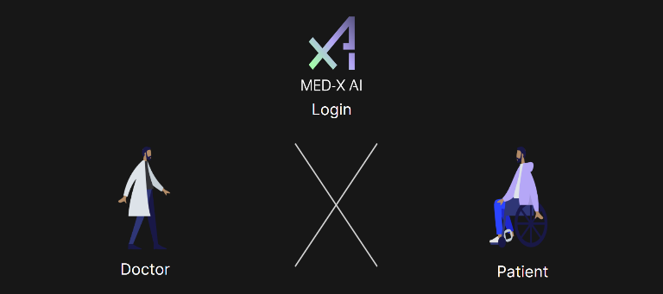

Fig 1. Home Login Page

Fig 2. Doctor Login Page

Fig 3. Patient Login Page

Fig 4. Doctor Registration Page

Fig 5. Patient Registration Page

Fig 6. Profile Update Page

Fig 7. Dashboard (Recent Report) Page

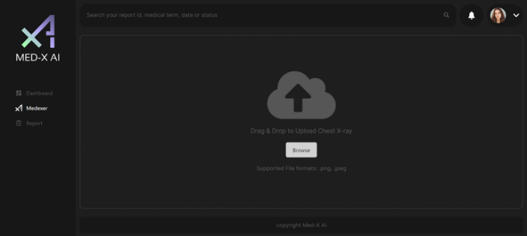

Fig 8. X-Ray Upload Page (Medexer)

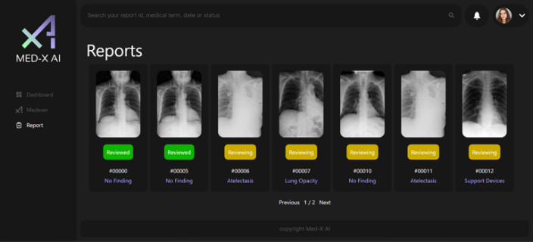

Fig 9. Report Gallery (Stored Reports) Page

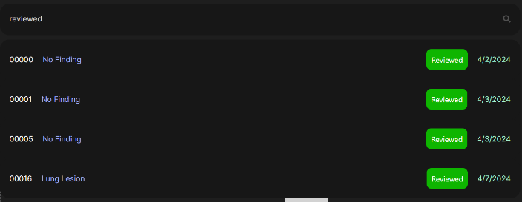

Fig 10. Search Reports by Review Status

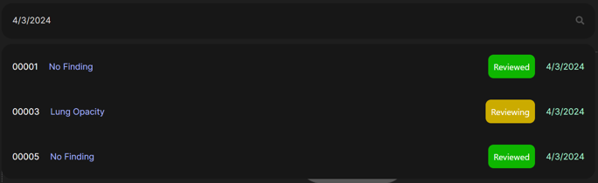

Fig 11. Search Reports by Date

Fig 12. Search Reports by Diagnosis

Fig 13. Doctor’s Comment Report Page

Fig 14. Notification

1. Conclusion

Med-X AI, the Thorax Disease Detector, evaluates chest X-ray images through CNN classification while connecting radiologists, physicians, and patients within the same application. With the automated identification of 14 conditions being 93% accurate, radiologists and physicians continue to have an integral role in final patient diagnosis. However, this method of AI thorax disease detection aids in communication between corresponding users, increases health literacy, and mitigates radiologist workload.

Further additions to Med-X AI can enhance the application’s diagnosis and user experience. Future scopes of this work may include continued improvement to the CNN model to increase disease classification accuracy and test new developments in machine learning algorithms. A method for a patient and physician to contact one another through direct messaging in the portal can also be developed to improve communication.

Additionally, research and testing to implement a display of multiple preliminary classified conditions with their match percentages for each X-ray uploaded may improve disease identification. As opposed to evaluating one condition with the highest percent of detection, a physician can then have a more comprehensive result from the CNN model to diagnose from.

The development of AI thorax disease detection is an emerging topic with significant potential for its implementation in healthcare. This technology can be expanded to include other body X-ray imaging. Med-X AI is taking notable steps in advancing the radiology practice.

References

1. National Institute of Biomedical Imaging and Bioengineering, “X-rays | National Institute of Biomedical Imaging and Bioengineering,” *NIH*, Jun. 2022. https://www.nibib.nih.gov/science-education/science-topics/x-rays (accessed Apr. 02, 2024).
2. OrthoInfo, “X-rays, CT Scans and MRIs - OrthoInfo - AAOS,” *Aaos.org*, Nov. 2023. https://orthoinfo.aaos.org/en/treatment/x-rays-ct-scans-and-mris/ (accessed Apr. 02, 2024).
3. D. of H. & H. Services, “X-ray examinations,” *www.betterhealth.vic.gov.au*, Feb. 06, 2019. https://www.betterhealth.vic.gov.au/health/conditionsandtreatments/x-ray-examinations (accessed Apr. 02, 2024).
4. R. Alexander *et al.*, “Mandating Limits on Workload, Duty, and Speed in Radiology,” *Radiology*, vol. 304, no. 2, pp. 274–282, Aug. 2022, doi: https://doi.org/10.1148/radiol.212631.
5. D. Forsberg, B. Rosipko, and J. L. Sunshine, “Radiologists’ Variation of Time to Read Across Different Procedure Types,” *Journal of Digital Imaging*, vol. 30, no. 1, pp. 86–94, Oct. 2016, doi: https://doi.org/10.1007/s10278-016-9911-z.
6. F. J. Lexa and S. Jha, “Artificial Intelligence for Image Interpretation: Counterpoint—The Radiologist’s Incremental Foe,” *American Journal of Roentgenology*, vol. 217, no. 3, Feb. 2021, doi: <https://doi.org/10.2214/ajr.21.25484>.
7. J. Irvin et al., "CheXpert: A Large Chest Radiograph Dataset with Uncertainty Labels and Expert Comparison," arXiv preprint arXiv:1901.07031, 2019.
8. S. Rajaraman, S. Sornapudi, P. O. Alderson, L. R. Folio, and S. K. Antani, "Chest X-ray analysis empowered with deep learning: A systematic review," Diagnostics, vol. 12, no. 8, p. 1970, 2022.
9. M. Bielówka et al., "Multi-Label Classification of Chest X-ray Abnormalities Using Transfer Learning Techniques," Sensors, vol. 22, no. 21, p. 8380, 2022.
10. Chong, Chak Fong & Yang, Xu & Wang, Tenglong & Ke, Wei & Wang, Yapeng. (2023). Category-Wise Fine-Tuning for Image Multi-label Classification with Partial Labels. 10.1007/978-981-99-8145-8_26.
11. Yuan, Z. (2023). LibAUC: A deep learning library for X-risk optimization (arXiv:2306.03065). arXiv. https://arxiv.org/abs/2306.03065